Asia-China-Shang-Chariot Head

"Old Chinese Zhou Dynasty bronze chariot head. Beautiful patina and coloring. The wooden pole is brittle and fragile. Inherited from a late relative."

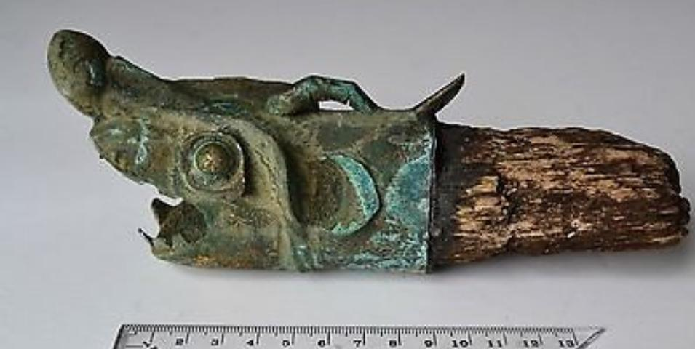

This ancient Chinese chariot ([戰車](http://en.wiktionary.org/wiki/戰車) , p. *zhànchē* lit. "war vehicle") fitting on the yuán or draught pole possibly in the form of an alligator was probably from an entombment of a military commander who had used the alligator as an apotropaic emblem in his career as a charioteer.

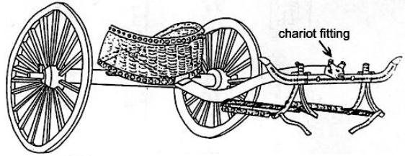

An ancient Chinese chariot ([戰車](http://en.wiktionary.org/wiki/戰車) , p. *zhànchē* lit. "war vehicle") with its alligator snout fitting (length 16.6 cm.) as reconstructed on the 3 m. long yuán or draught pole was excavated from burial M20 at Anyang Xiaotun. Chariot reconstruction after Shih Chang-ju, Hsiao-t'un: Pei-tsu Mu-tsang, *Academia Sinica* 22(1950), p. 28

The alligator as an apotropaic emblem on the battlefield suggests that its use was associated with its pugnacious ability to subdue its enemy by subduing and drowning it with great force, and when this power was transferred to the field of battle it would make the alligator chariot a formidable weapon through the power it derived from its animal emblem. Archaeological evidence indicates that the chariot in ancient China was used as an attack and pursuit vehicle on the Central Plains from around 1200 BCE (Beckwith 2009: 43, Ebrey 2006: 14). However, the invention of the chariot was traditionally assigned by the first century CE philologist Xǔ Shèn to the legendary Xia Dynasty minister [Xi Zhong](http://en.wikipedia.org/wiki/Xi_Zhong) who successfully used it at the Battle of Gan (甘之战) *ca*. 2100 BCE (Xǔ Shèn, wg [Hsü Shen p] *Shuowen Jiezi,* [*Zhu Pian*](http://en.wikipedia.org/w/index.php?title=Zhu_Pian&action=edit&redlink=1) (玉篇), "Chariot Section" (车部)). So in Chinese tradition the chariot had an ancient past that rendered it especially auspicious. And this auspiciousness was commuted to military commanders who used it in the late Shang period as a mobile staging device from which to direct troop movement, Therefore, the use of the alligator emblem on the chariot by a commander at Anyang, which was the center of power of the Shang state, would have indicated the high regard the commandery had for this apotropaic animal. This may be the reason why the use of the alligator motif is so rare in the archaeological record, because it may have had a restricted use to those in the high command. Located near the Zhangjiapo Village in Mawang Town of Chang'sn District in Xian City and on the west bank of the Fenghe River, the Western Zhou Chariot Burial Pit is a typical sacrificial tomb of slave society. Archeologists have confirmed that the system of burying living people with the dead began in the Shang Dynasty (16th - 11th century BC). At that time, many alive slaves were buried with the dead, killed or after committing a suicide for the slave owner and nobles believed that the tombs were their residence in the spiritual world after their death. The **Chinese alligator** (揚子鱷, (yáng zǐ è) *Alligator sinensis*) is one of only two known living species of *Alligator*, now native only to the lower reaches of the Yangtze River, along Yijiang and Taihu river-basin swamps and in the provinces of Jiangsu, Zhejiang, and Anhui. However, in the past its range was throughout most of southern China. Unlike its cousin, the American alligator, the Chinese alligator is armored over its entire body a feature of only a few Crocodilia, the order of large reptiles dating back 83.5 million years and named for the so called "pebble-worm" (κροκόδειλος Greek) texture of its armor, which resembles the Chinese Shang bronze body textures of ritual containers. However, while the term crocodilian can be used as an adjective for these creatures, their true animal analogue is that of the Chinese alligator which is not a crocodile.

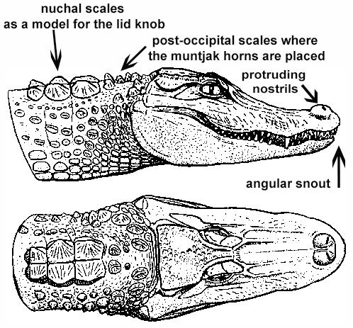

*Alligator sinensis* after Wermuth & Fuchs (1978)

